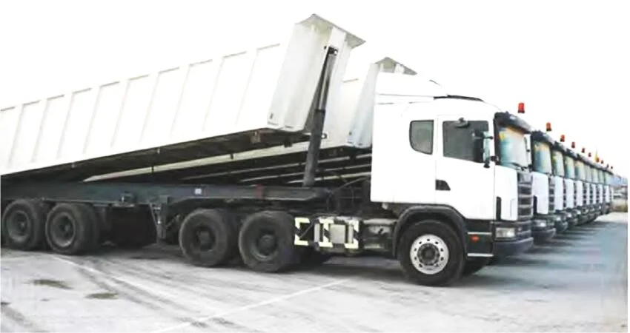

ARKAN BUILDING MATERIALS
PREMIUM UAE CORPORATE PROFILE

Chairman's Message
ARKAN is committed to delivering reliable building material supply and logistics solutions that support the UAE's continued growth and development.

Company Profile
Trusted supplier of aggregates, sands, road materials, cement and project supply solutions across the UAE.

Vision
To become a preferred building materials supply partner throughout the UAE.

Mission
To provide dependable supply solutions through professional service, strong supplier relationships and efficient logistics.

Why ARKAN
Reliable Supply Network, Fast Quotations, Flexible Deliveries, Infrastructure Support, Professional Customer Service and UAE-Wide Coverage.

Transportation & Logistics
ARKAN coordinates material deliveries and logistics support for infrastructure, industrial, commercial and residential projects.

Industries Served
Infrastructure, Roads, Ready-Mix, Contractors, Industrial Facilities, Commercial Developments and Government Projects.

Cement Trading & Bulk Logistics
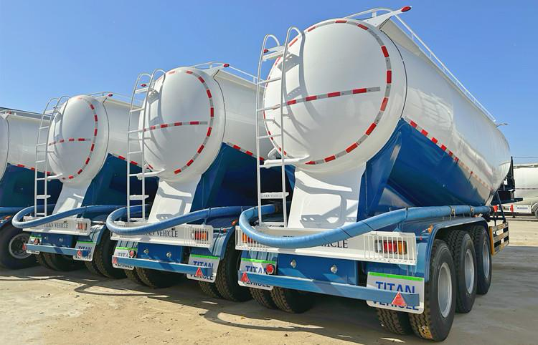
ARKAN supplies bulk cement solutions to ready-mix plants, contractors, infrastructure projects, precast manufacturers and industrial clients across the UAE.
- Bulk Cement Supply
- Cement Tanker Logistics
- Project Deliveries
- Flexible Scheduling

0–5mm Crushed Sand
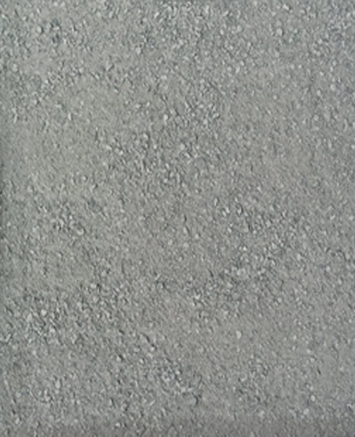
Product | 0–5mm Crushed Sand
Supply | Bulk & Project Supply
Coverage | UAE Wide
Applications | Construction, Infrastructure & Industrial Projects

0–5mm Washed Sand
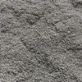
Product | 0–5mm Washed Sand
Supply | Bulk & Project Supply
Coverage | UAE Wide
Applications | Construction, Infrastructure & Industrial Projects

Dune Sand

Product | Dune Sand
Supply | Bulk & Project Supply
Coverage | UAE Wide
Applications | Construction, Infrastructure & Industrial Projects

5–10mm Crushed Aggregate
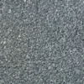
Product | 5–10mm Crushed Aggregate
Supply | Bulk & Project Supply
Coverage | UAE Wide
Applications | Construction, Infrastructure & Industrial Projects

10–20mm Crushed Aggregate
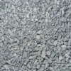
Product | 10–20mm Crushed Aggregate
Supply | Bulk & Project Supply
Coverage | UAE Wide
Applications | Construction, Infrastructure & Industrial Projects

20–40mm Crushed Aggregate

Product | 20–40mm Crushed Aggregate
Supply | Bulk & Project Supply
Coverage | UAE Wide
Applications | Construction, Infrastructure & Industrial Projects

Road Base

Product | Road Base
Supply | Bulk & Project Supply
Coverage | UAE Wide
Applications | Construction, Infrastructure & Industrial Projects

Sub Base
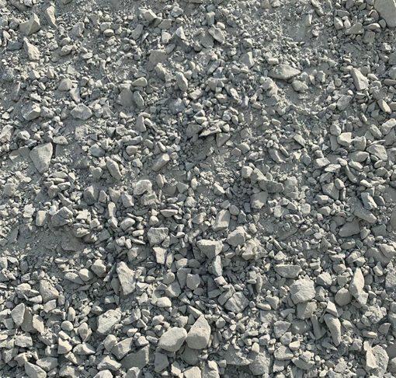
Product | Sub Base
Supply | Bulk & Project Supply
Coverage | UAE Wide
Applications | Construction, Infrastructure & Industrial Projects

Contact ARKAN
Email: info@arkan.cm
Phone: +971 50 540 0494
Website: www.arkan.com

